Create a table table name student new

Field name reg no and its data type number size

Next field name varchar name sizE:

DATE OF BIRTH DATATYPE DATE?

SOULTION SQL CODE:

PRIMARY KEY:

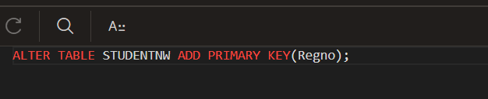

ADDING COLUMN:

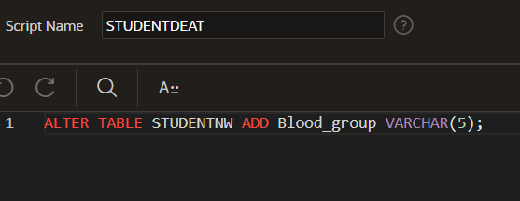

UPDATED TABLE:

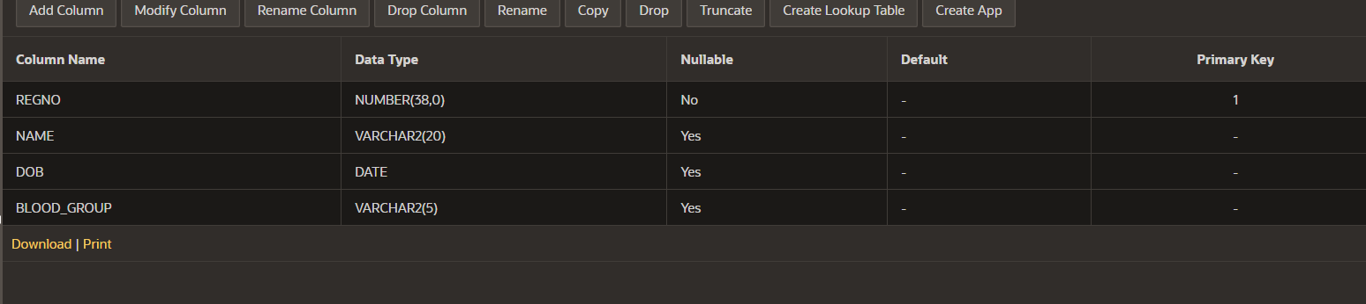

ADDING COLUMN:

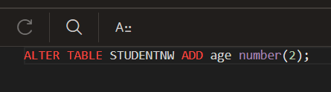

UPDATED TABLE: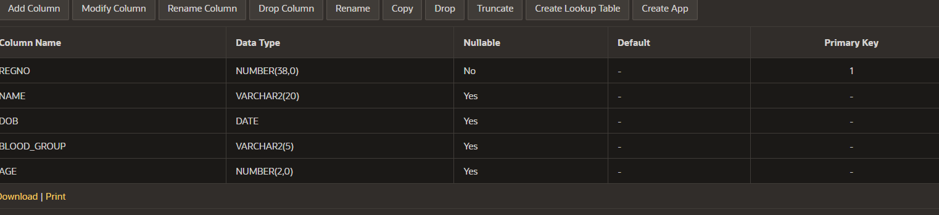

REMOVING OR DROPPING COLUMN:

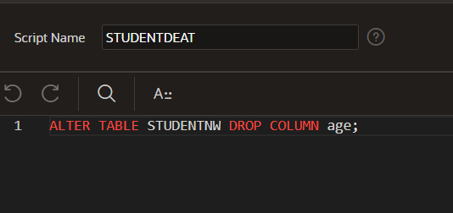

UPDATED TABLE:

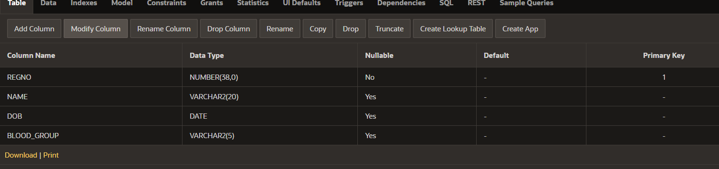

RENAME OF THE COLUMN:

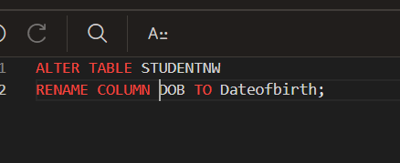

UPDATED TABLE: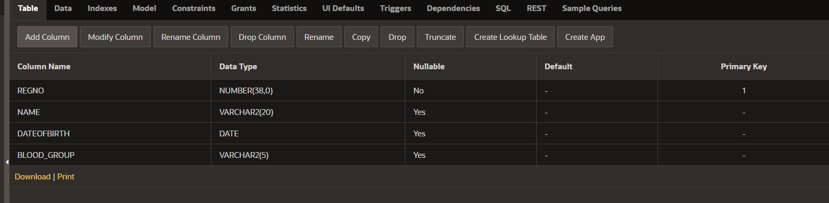

MODIFY DATE TYPE:

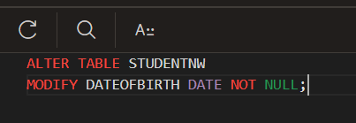

NAME DATATYPE CONERT USING MODIFY:

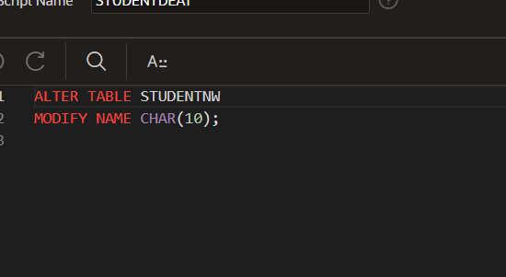

INSERT THE DATA VALUES:

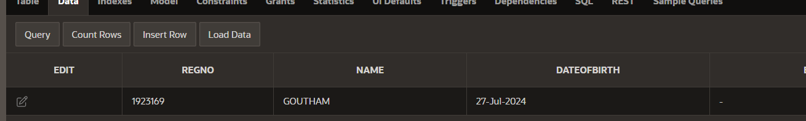

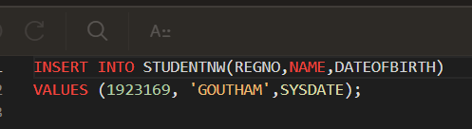

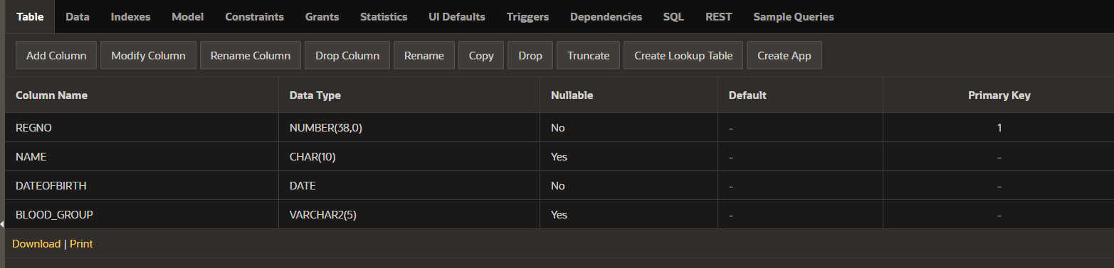

INSERTING MULTIPLE DATA VALUES:

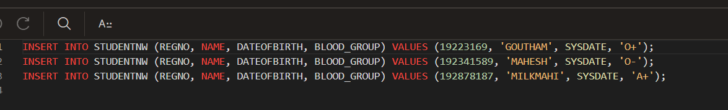

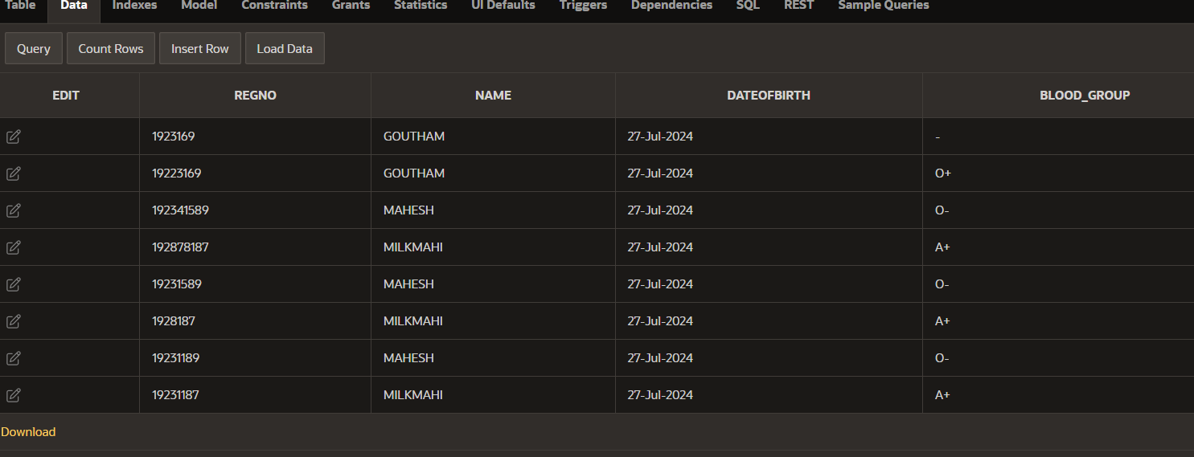

DELETING ROW FROM TABLE:

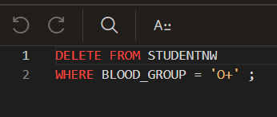

UPDATED TABLE: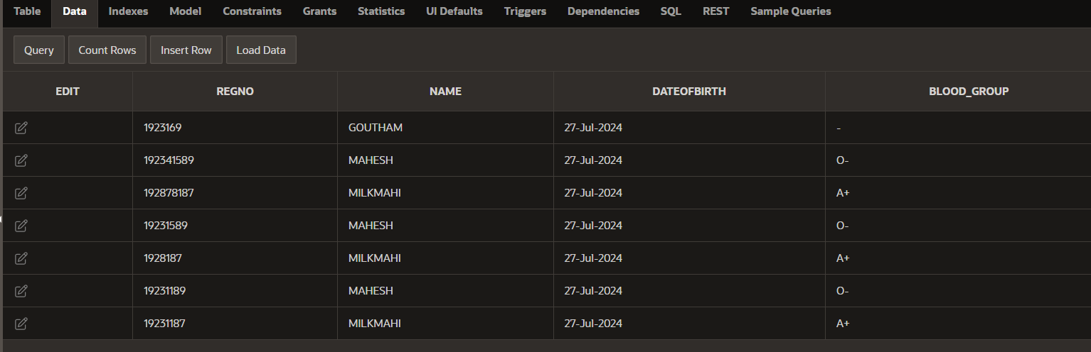

DELETING THE TABLE:

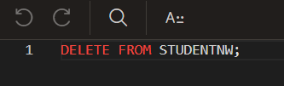

UPDATED TABLE:

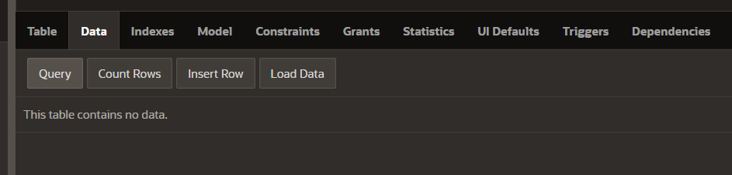

CREATE A NEW TABLE:

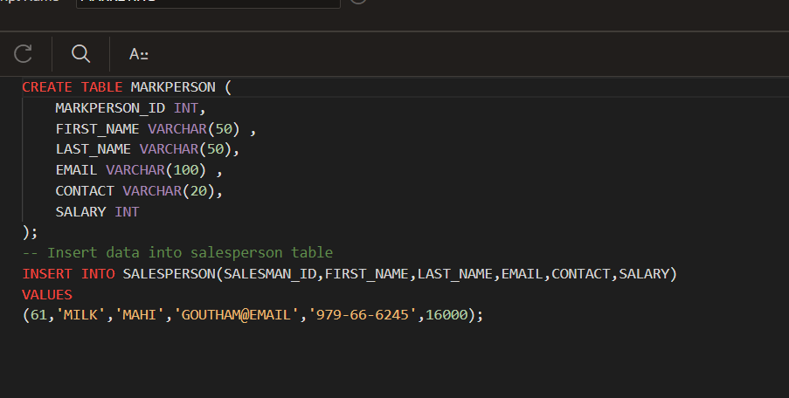

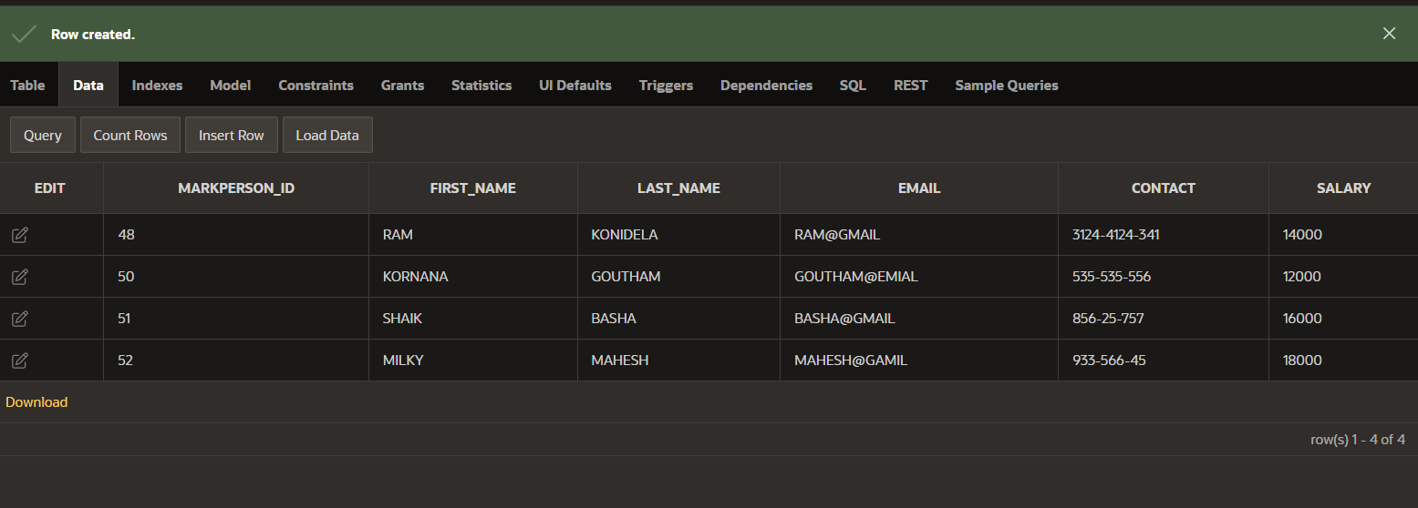

USING AND OPERATOR:

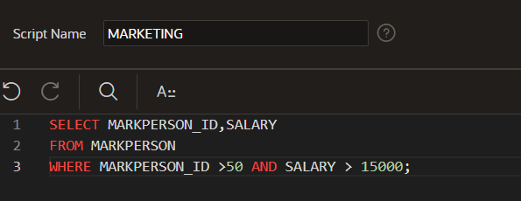

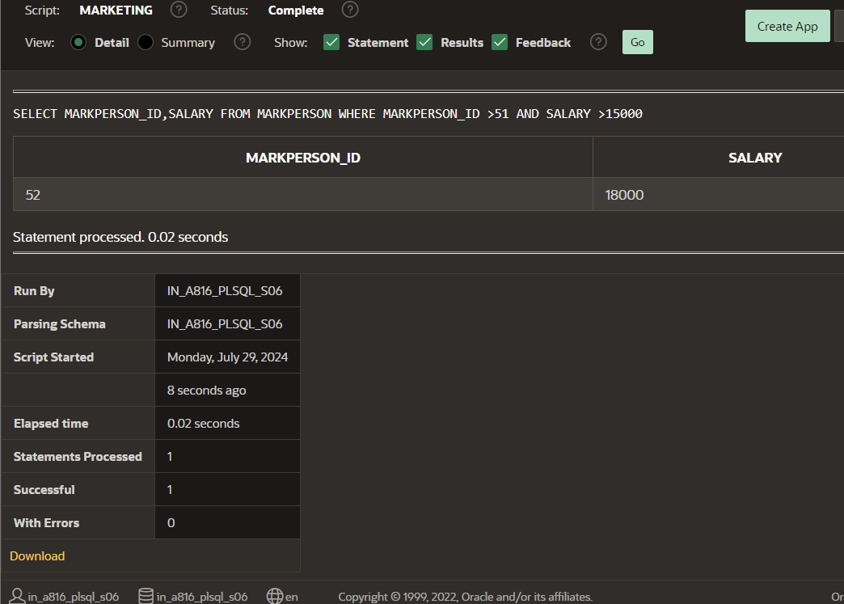

USING OR OPERATOR:

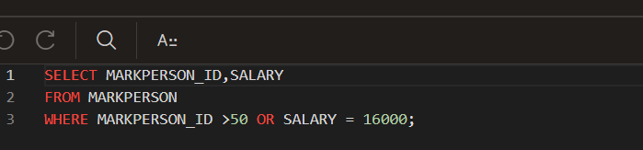

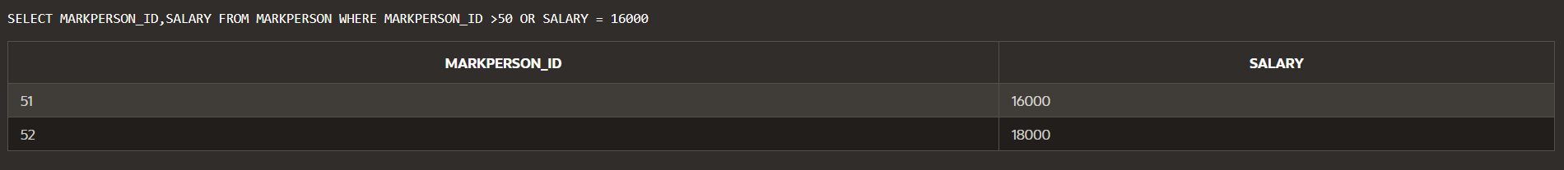

USING NOT OPERATOR:

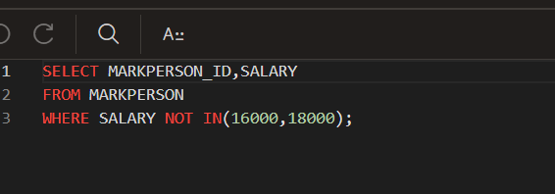

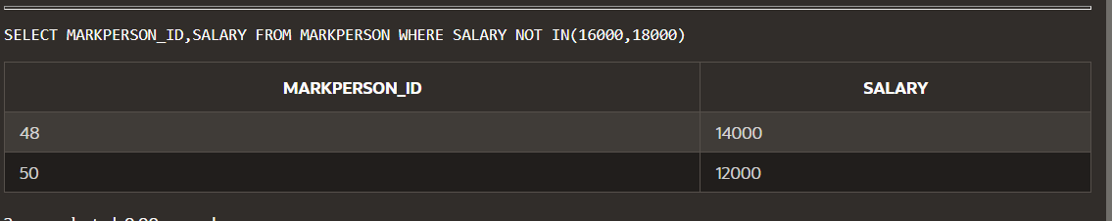

AS KEYWORD TO OPERATION:

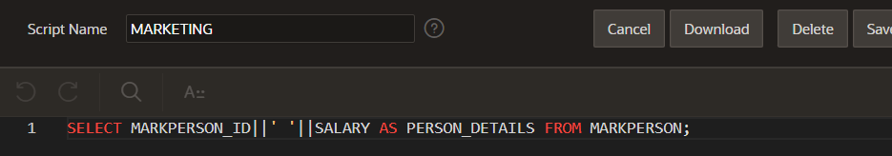

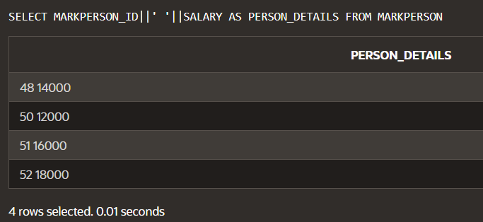

USING LIKE KEYWORD TO FOUND SIMILAR:

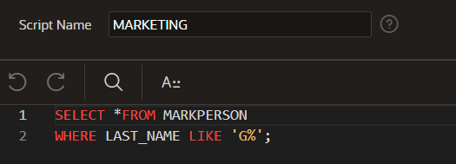

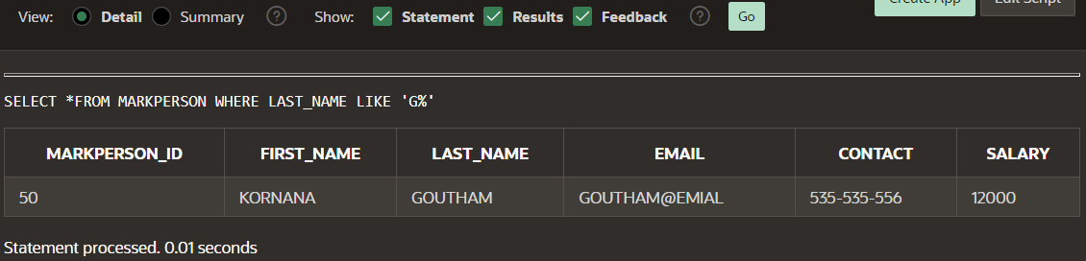

CREATE TABLE OF ORDERS:

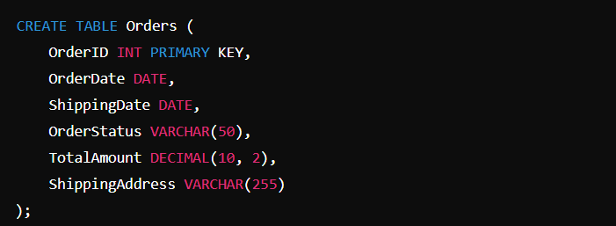

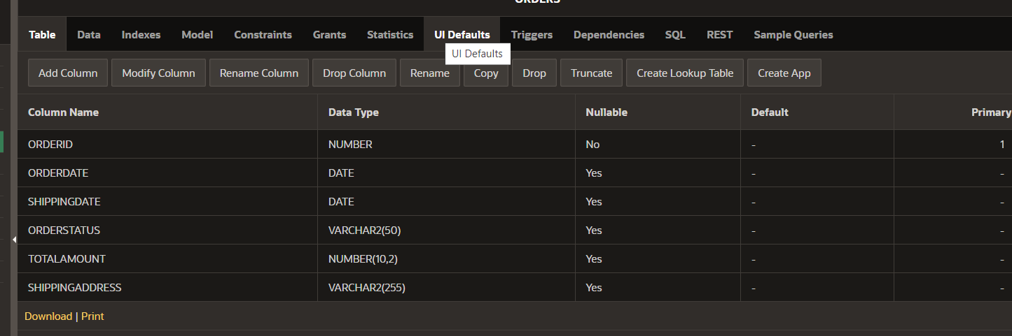

CREATE TABLE OF PERSON:



CROSS JOIN OF EMPLO AND DEP TABLE: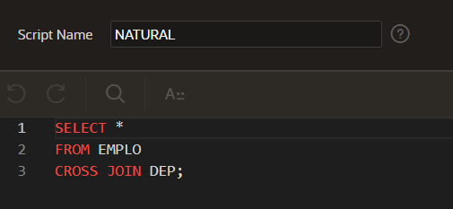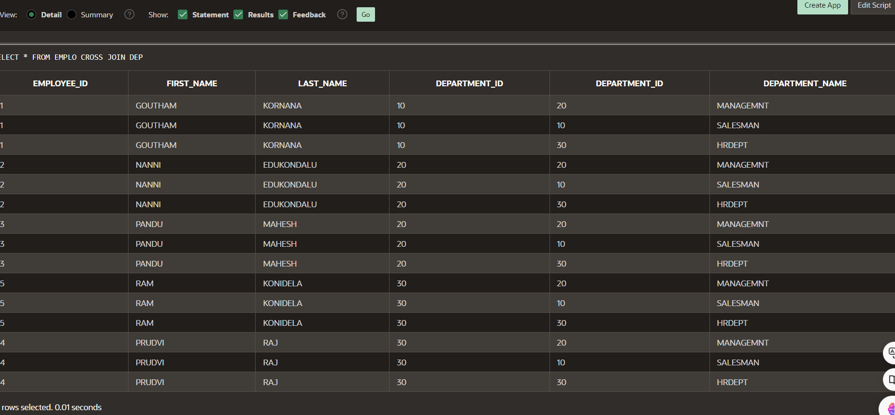

NATURAL JOIN OF EMPLO AND DEP :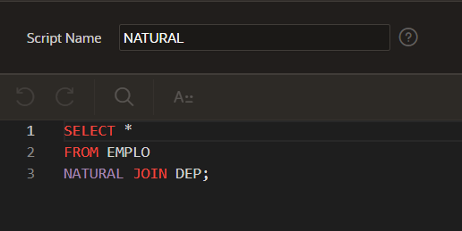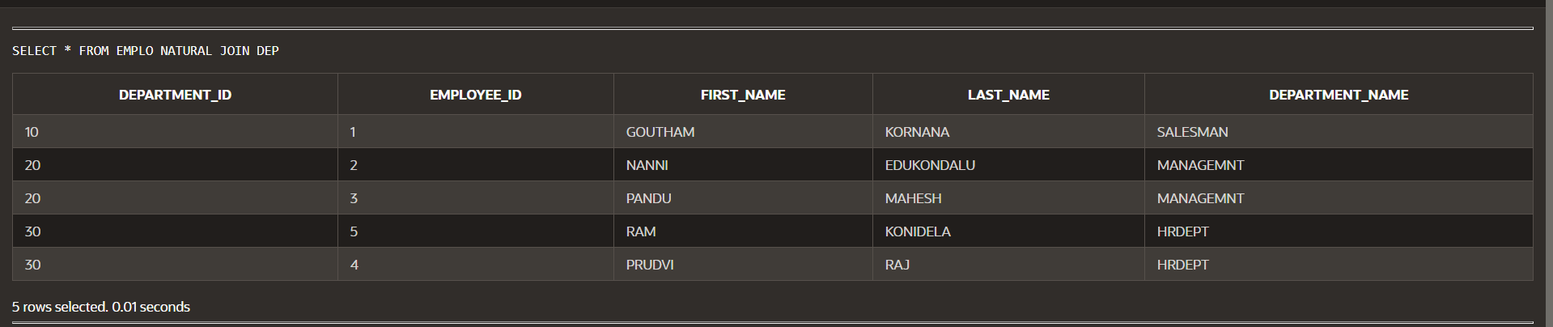CREATING EMPLO TABLE:

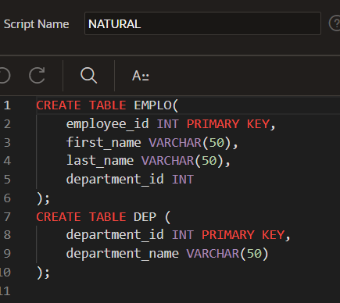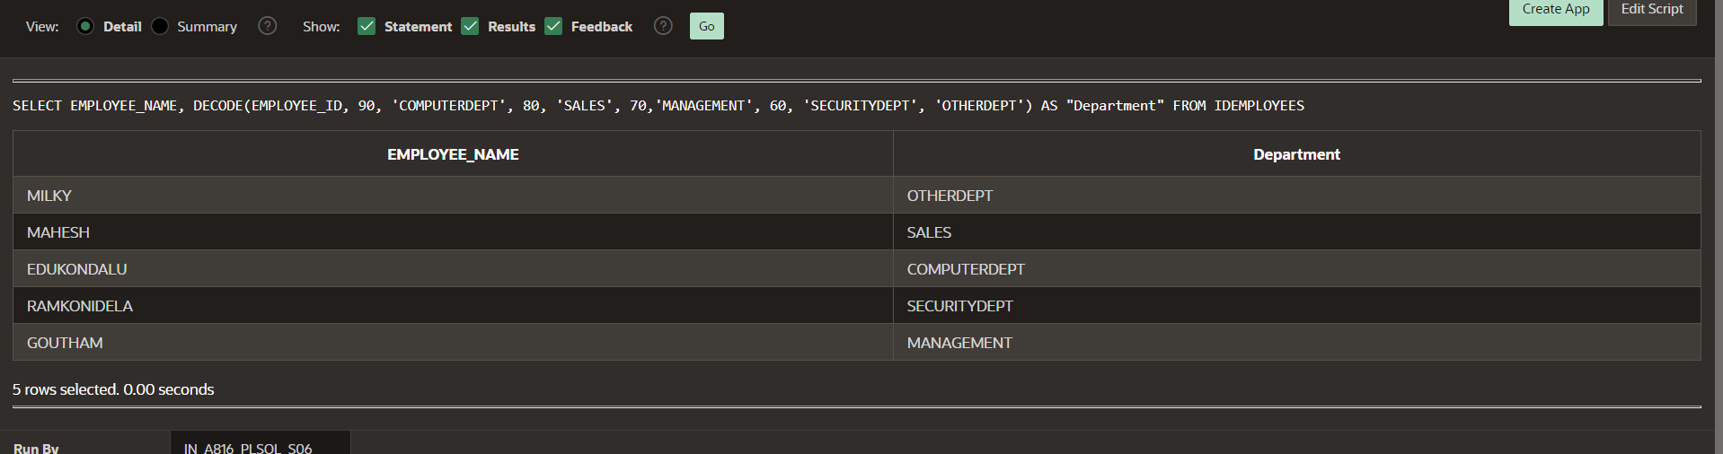

DECODE:

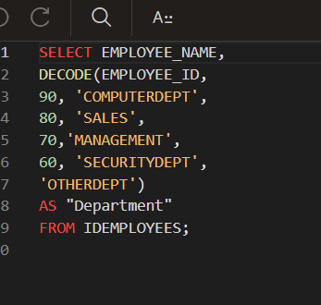

CASE:

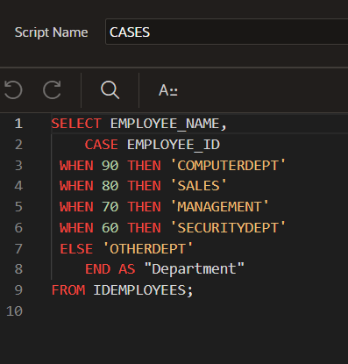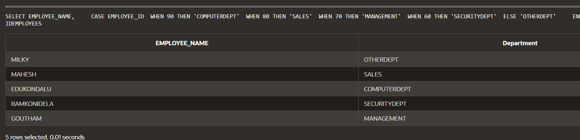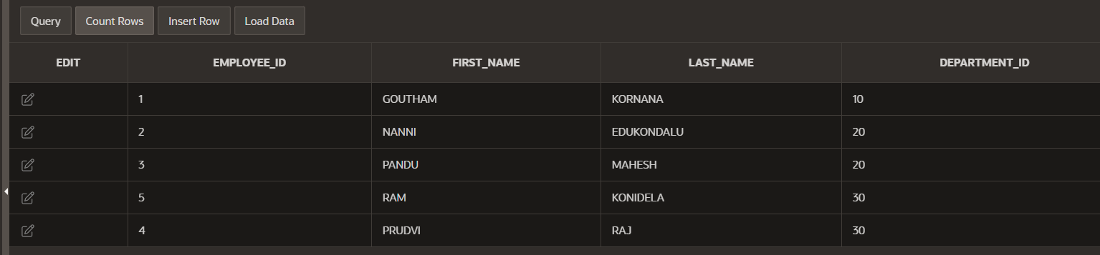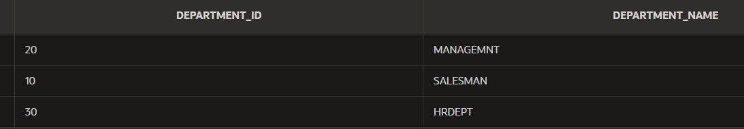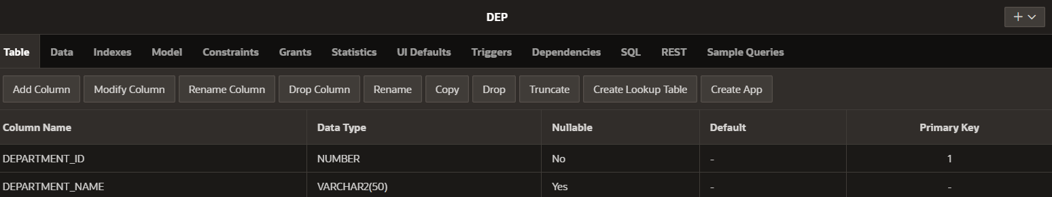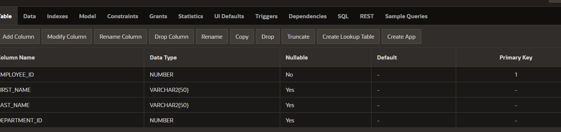



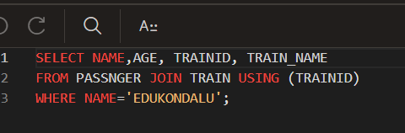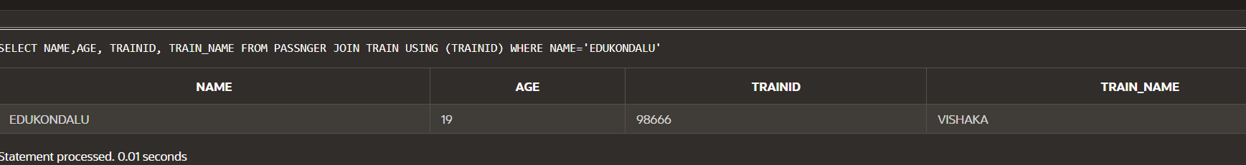

JOIN:

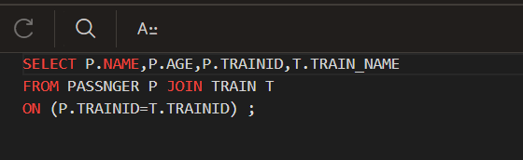

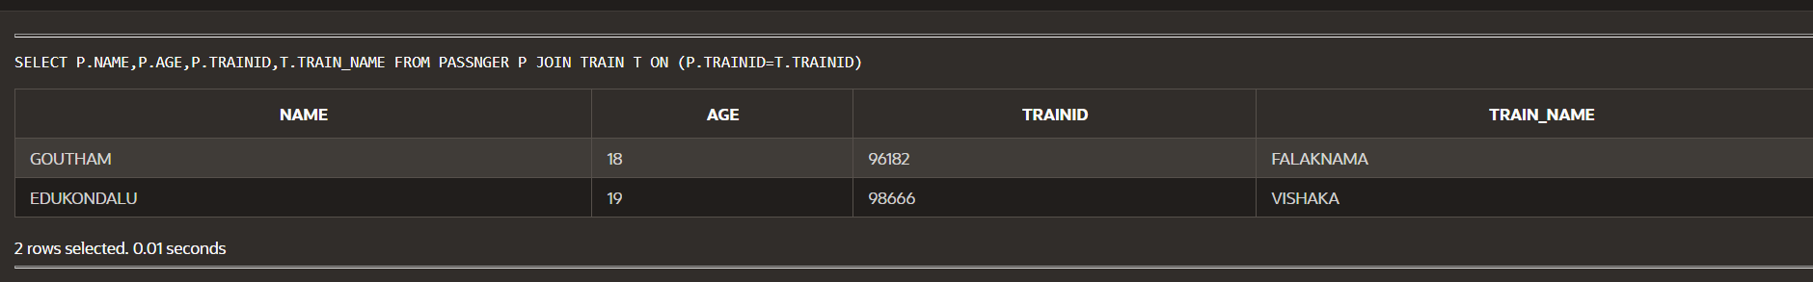

JOIN USING WHERE: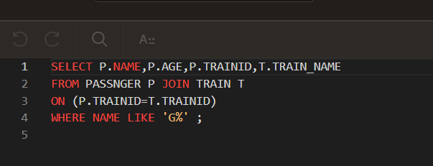

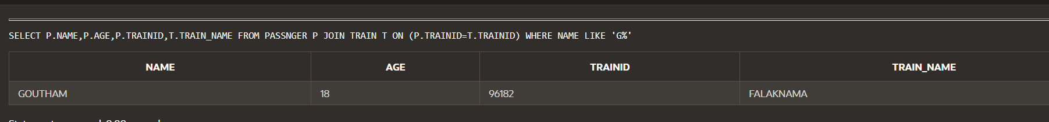

LEFT OUTER JOIN:

